Notes on Arxiv Research Paper – WDSEnv

Context
- Models a municipal water distribution system, where the objective is to ensure a consistent supply to meet fluctuating residual demand.
- Has continuous state spaces, discrete action spaces.
- Simulates the evolution of a hydraulic network in charge of dispatching water across a residential town.
- Network is composed of different entities, such as storage tanks, pumps, pipes, junctions, and reservoirs and the main objective of the system is the safety of the network.
- Runtime per episode for WDSEnv is 72.932s.

Objective
- Need to ensure optimal management of hydraulic pumps, which oversee deciding how much water should be collected from reservoirs and dispatched to the network.
- Pumps’ controller must guarantee network resilience by maximizing the demand satisfaction ratio (DSR) while minimizing the risk of overflow.
- Formally, the objective is:
$$max\sum_{t=1}^{T}{[r_{DSR}\left(a_{t}\right)+r_{of}(a_{t})]}$$
- $r_{DSR}\left(a_{t}\right)∈\left[0,1\right]$ is the ratio between the supplied demand and the expected demand at time t.
- $r_{of}\left(a_{t}\right)∈\left[0,1\right]$ is the normalised penalty associated with the tank’s overflow risk.

Observation Space
- Observation space includes internal state of the network and an estimation of the global demand profile that the system is asked to deal with.
- Formally, the observation space is:
$$s_{t}=(h_{t},p_{t},{\hat{d}}_{t},\cos\left(φ_{t}^{d}\right),\sin\left(φ_{t}^{d}\right))$$
- $h_{t}∈ R^{L}$ is a vector of L tank levels at time t
- $p_{t}∈ R^{J}$ is a vector of J junction pressures at time t
- ${\hat{d}}_{t}$ is the estimated total demand at time t
- $φ_{t}^{d}∈[0,2π]$ is the angular position of the clock in a day
- $φ^{d}= \frac{2πτ_{d}}{T_{d}}, {where τ}_{d}∈[0,T_{d}]$ denotes the time of day in seconds and T_{d} is the total number of seconds in a day (86400).
- Although all tanks must be monitored, we can reduce dimensionality of the observation space by considering only junctions placed in strategic positions.

Action Space
- The discrete action variable $a_{t}∈N$ can assume values in {0,…,2^{P}-1}, with P number of pumps within the system.
- The action determines the combination of open/closed pumps.

Reward Function
- Instantaneous reward given by the environment is
$${r_{t}=r}_{DSR,t}\left(a_{t}\right)+r_{of, t}(a_{t})$$
- $r_{DSR,t}\left(a_{t}\right)=\frac{\sum_{j=1}^{J}{d_{j,t}}}{\sum_{j=1}^{J}{{\overline{d}}_{j,t}}}$ , where d_{j,t} denotes the actual supplied demand at junction j and time t, and ${\overline{d}}_{j,t}$ is the corresponding expected demand.
- This term rewards the agent proportionally to the fraction of demand satisfied, with $r_{DSR,t}\left(a_{t}\right)=1$ indicating perfect demand satisfaction
- 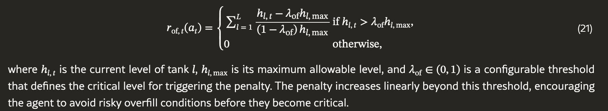

Benchmarking
- The WDSEnv is benchmarked adopting DQN, which is compared with different rule-based baselines: the Random policy, P78 and P79 policies, which act by keeping active only the relative pump (namely P78 or P79, respectively), and the Default policy, which executes the default control rules contained within the .inp configuration file of the network, changing the control action depending on the current tank level.
- DQN achieves a higher level of resilience with respect to other baselines.
- Second plot shows that it has a more consistent behaviour and low variance, a crucial characteristic for the resilience and safety of the water network.
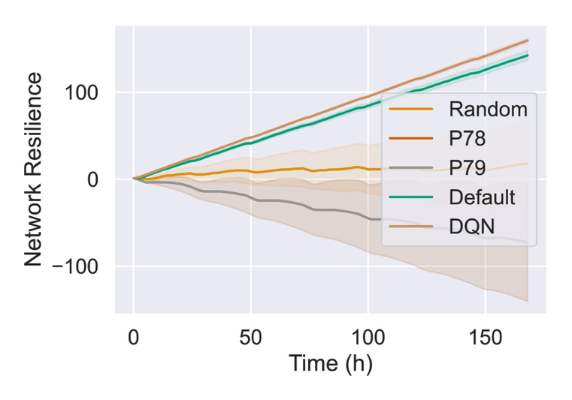
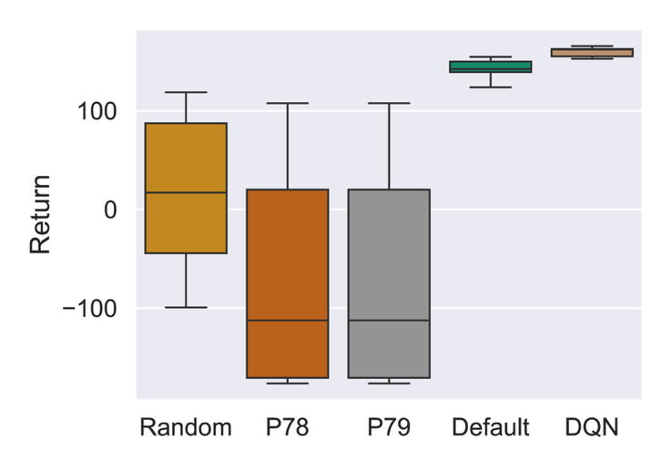

Dataset
- WDSEnv relies on synthetically generated residential water demand datasets using STREaM, a stochastic simulation model to generate synthetic time series of water end uses with diverse sampling resolutions.
- STREaM is calibrated on a large dataset that includes observed and disaggregated water end-uses from U.S. single-family households.
- We categorized the generated profiles into one of three classes, representing increasing levels of stress imposed on the water distribution system: normal, stressful, or extreme. These classes are designed to facilitate the analysis of network resilience under varying conditions.

Environment Details
- Both the hydraulic step and the demand pattern step are set to one hour, aligning with the temporal resolution typically used in real-world water management systems.
- The simulator models the water distribution system as a graph composed of nodes and links.
- Tanks store water and help meet demand during peak usage or scarcity and must maintain their water levels within operational boundaries
- Junctions are expected to maintain adequate pressure to ensure service reliability
- Each junction is assigned a base demand value in the .inp file, which represents the nominal water demand at that location.
- The Demand Satisfaction Ratio (DSR) is used as a key indicator of how well the actual demand is met over time.
- To simulate dynamic and diverse operational conditions, we introduce time-varying demand profiles that modulate the base demand values to reflect normal, stressful, and extreme scenarios.

Limitations
- The main limitations of WDSEnv stem from the underlying simulator. First, from a modeling perspective, the environment does not allow for fine-grained control of pumps beyond simple on/off status, since features such as variable speed control are not supported by either Epynet or Epanet.
- Second, running experiments within this environment is computationally expensive, as reported in Table 2. While our experiments are conducted on a relatively small network with a limited number of nodes and links, scaling to larger networks for benchmarking would require significantly more powerful hardware and the use of parallelization strategies.

Potential RL Algos
Algorithm | Best Used When... | Pros | Cons
Rainbow DQN | You want maximum sample efficiency on a pure discrete problem. | Very efficient; standard for discrete. | Can be unstable; many hyperparameters to tune.
PPO | You want a robust, "set it and forget it" solution. | Stable; easy to use; rarely crashes. | Slower to learn (needs more simulation steps).
A2C | You need fast training speed (wall-clock time). | Simple; parallelizes well. | Often performs worse than PPO/DQN.

